Cold Compression Therapy
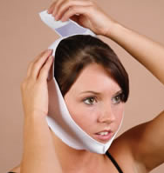
Both Hot and Cold therapy packs can be very effective in helping a patient recover from surgery. Unlike conventional ice packs or a soggy bag of frozen peas, Cool Jaw® hands free cold therapy can mold to the contours of the face, will not leak, and are light weight, ensuring proper pressure. Cold therapy has been shown to increase patient comfort and may decrease facial swelling during the initial after surgery time period.
Cool Jaw® products are ideal for;
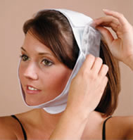
- Wisdom teeth extractions
- Reconstructive jaw surgery
- Implant surgery
- TMJ pain

Heat Therapy
The gel packs can also be used as heat therapy to reduce swelling and bruising, or to address minor aches and pains, soothing the area of discomfort. You should consult with your doctor about when to begin using hot packs, but usually heat can be used around 3 to 4 days after surgery. Hot packs can be warmed by hot or boiling water, as well as in the microwave for 5 second intervals until the desired temperature is achieved.

